**EECS 360**

**Lab 13**

**11/29/16**

**Chen Long**

1. **Objective**

This lab is really similar than lab 12 besides that we are doing z domain instead of S domain.

1. **Description**

We do exactly the same thing as lab 12, what we need to change is we are supposed to use zplane to find the poles and zeros and freqz to find the magnitude and angle.

1. **Result**

Since Z stands for e-st, therefor the graph is supposed to look like a circle, and the result shows exactly what we expected.

1. **Result**

This lab isn’t too much new compare to the last one, what I found is interesting is that the poles and zeros are a little bit different. I should look more into it sometime!

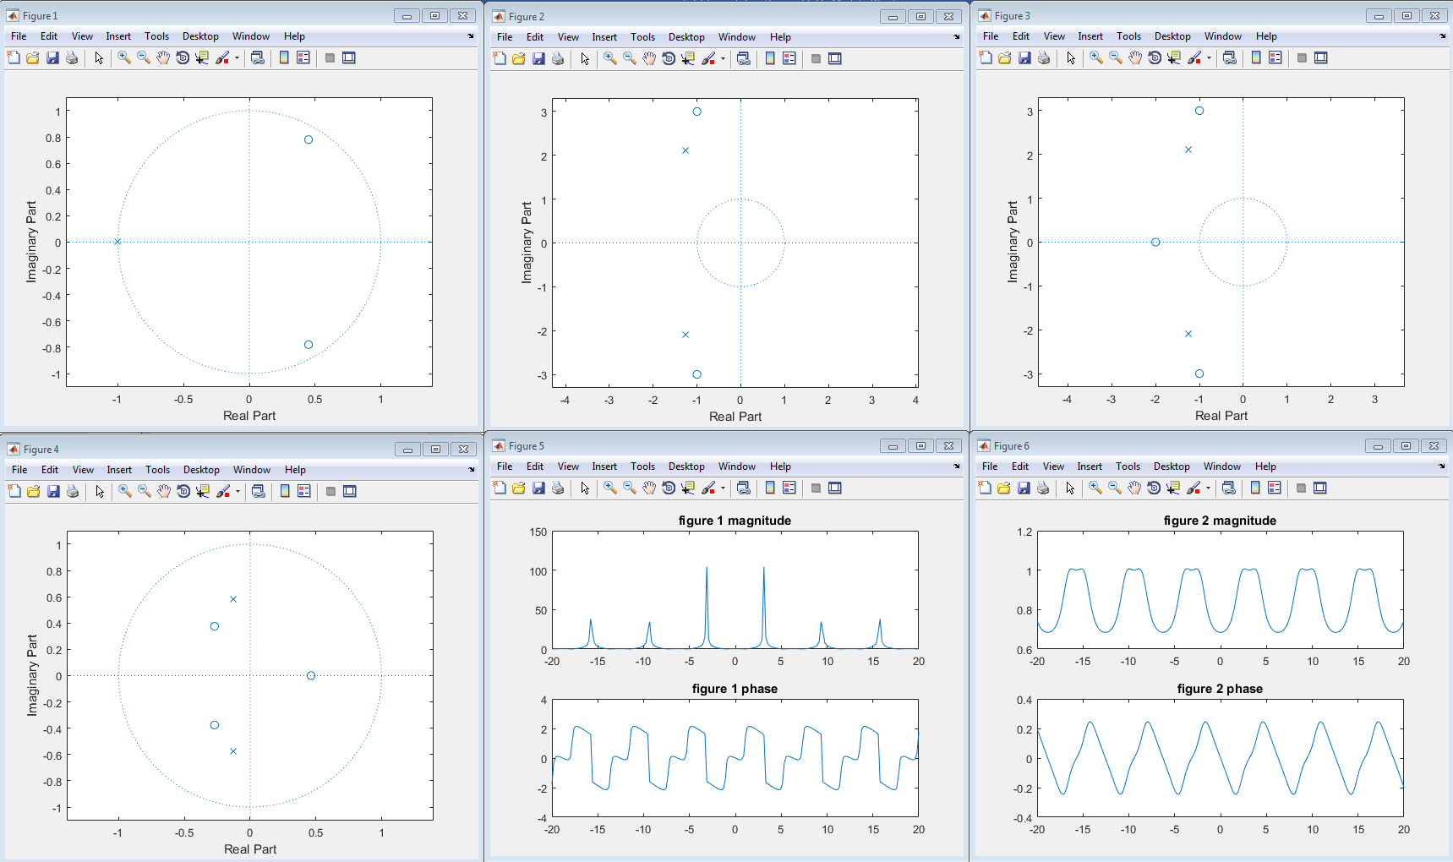

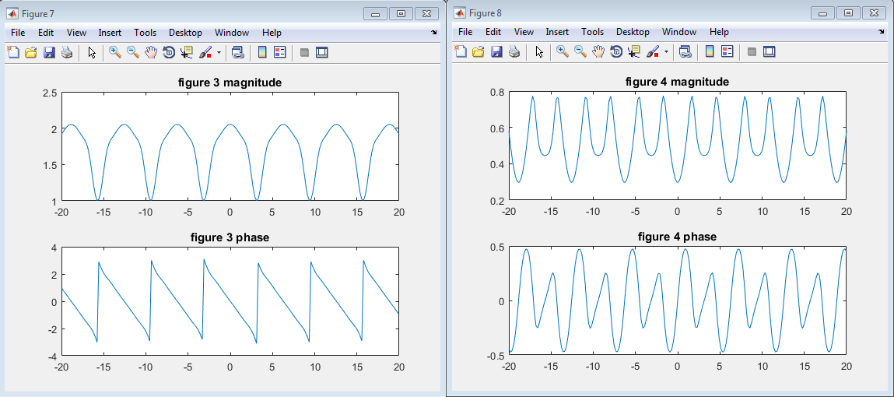  
MATLAB CODE

clear all;

% part 1

w = linspace(-20, 20, 200);

figure(1);

a = [1 1];

b = [1 -0.9 0.81];

xs = roots(b);

ys = roots(a);

zplane(xs, ys);

% freqz

figure(5);

H = freqz(b, a, w);

subplot(211);

plot(w, abs(H));

title('figure 1 magnitude');

subplot(212);

plot(w, angle(H));

title('figure 1 phase');

% 2

figure(2);

a = [2 5 12];

b = [1 2 10];

xs = roots(b);

ys = roots(a);

zplane(xs, ys);

% freqz

figure(6);

H = freqz(b, a, w);

subplot(211);

plot(w, abs(H));

title('figure 2 magnitude');

subplot(212);

plot(w, angle(H));

title('figure 2 phase');

% 3

figure(3);

a = [2 5 12];

b = [1 4 14 20];

xs = roots(b);

ys = roots(a);

zplane(xs, ys);

% freqz

figure(7);

H = freqz(b, a, w);

subplot(211);

plot(w, abs(H));

title('figure 3 magnitude');

subplot(212);

plot(w, angle(H));

title('figure 3 phase');

% 4

figure(4);

a = [2 0.49 0.7];

b = [1 0.079 -0.0365 -0.099];

xs = roots(b);

ys = roots(a);

zplane(xs, ys);

% freqz

figure(8);

H = freqz(b, a, w);

subplot(211);

plot(w, abs(H));

title('figure 4 magnitude');

subplot(212);

plot(w, angle(H));

title('figure 4 phase');